Bước 1 : Tạo bảng : rails g scaffold <tên bảng> tên cột : kiểu dữ liệu

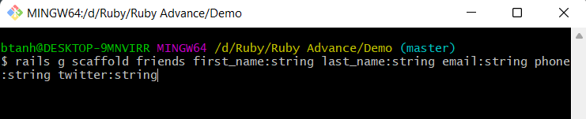

Bước 2: Kiểm tra trong file db > migrate

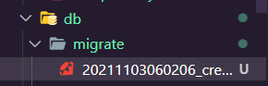

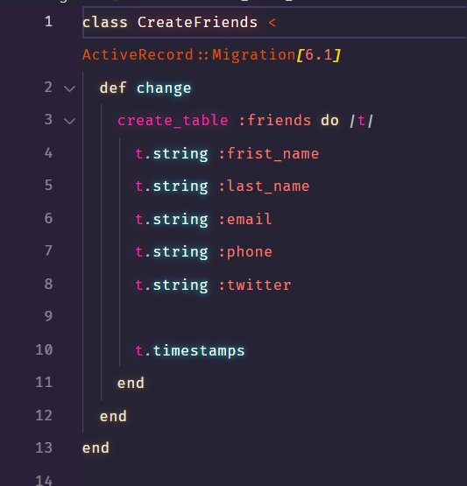

Bước 3 : Cài đặt csdl (file schema)

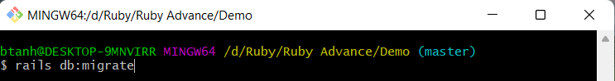

Bước 4: kiểm tra file table đã được cài đặt chưa

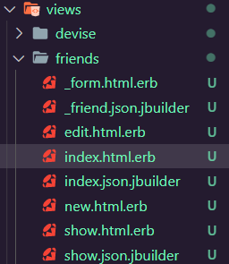

Bước 5 : bootstrap cho bảng

* File index.html.erb
* <h1>Friends List</h1>
* <table *class*="table table-striped table-bordered table-hover">
* <thead *class*="thead-dark">
* <tr>
* <th>Frist name</th>
* <th>Last name</th>
* <th>Email</th>
* <th>Phone</th>
* <th>Twitter</th>
* <th *colspan*="3"></th>
* </tr>
* </thead>
* <tbody>
* <% @friends.each do |friend| %>
* <tr>
* <td><%= friend.frist_name %></td>
* <td><%= friend.last_name %></td>
* <td><%= friend.email %></td>
* <td><%= friend.phone %></td>
* <td><%= friend.twitter %></td>
* <td><%= link_to 'Show', friend %></td>
* <td><%= link_to 'Edit', edit_friend_path(friend) %></td>
* <td><%= link_to 'Destroy', friend, method: :delete, data: { confirm: 'Are you sure?' } %></td>
* </tr>
* <% end %>
* </tbody>
* </table>
* <br>
* <%= link_to 'New Friend', new_friend_path,
* class: 'btn btn-dark'%>
* File edit.html.erb
* <h1>Editing Friend</h1>
* <%= render 'form', friend: @friend %>
* <%= link_to 'Show', @friend, class: 'btn btn-secondary' %>
* <%= link_to 'Back', friends_path, class: 'btn btn-dark' %>
* File show.html.erb

<div *class*="jumbotron">

  <h1 *class*="display-4">

    <%= @friend.frist_name %>

      <%= @friend.last_name %>

  </h1>

  <p *class*="lead">

  <p>

    <strong>Email:</strong>

    <%= @friend.email %>

  </p>

  <p>

    <strong>Phone:</strong>

    <%= @friend.phone %>

  </p>

  <p>

    <strong>Twitter:</strong>

    <%= @friend.twitter %>

  </p>

  </p>

  <hr *class*="my-4">

  <p>It uses utility classes for typography and spacing to space content out within the larger container.</p>

  <%= link_to 'Edit' , edit_friend_path(@friend), class: 'btn btn-secondary' %>

    <%= link_to 'Back' , friends_path, class: 'btn btn-dark' %>

</div>

Bước 6 : sửa file _header.html.erb

  <li *class*="nav-item">

          <%= link_to "Show Friend",

              friends_path,

              class:"nav-link" %>

          </li>

          <li *class*="nav-item">

          <%= link_to "Add Friend",

              new_friend_path,

              class:"nav-link" %>

          </li>

Bước 7: Kết quả

